String Function

1. Write a [MySQL](https://www.w3resource.com/mysql-exercises/string-exercises/) query to update the portion of the phone_number in the employees table, within the phone number the substring '124' will be replaced by '999'.

Ans:- UPDATE employees SET PHONE_NUMBER = REPLACE(PHONE_NUMBER,'124','999') WHERE PHONE_NUMBER LIKE '%124%';

1. Write a [MySQL](https://www.w3resource.com/mysql-exercises/string-exercises/) query to get the details of the employees where the length of the first name greater than or equal to 8.

Ans:- SELECT FIRST_NAME FROM employees WHERE CHAR_LENGTH(FIRST_NAME)>=8;

1. Write a [MySQL](https://www.w3resource.com/mysql-exercises/string-exercises/) query to display leading zeros before maximum and minimum salary.

Ans:- SELECT JOB_ID, LPAD(MIN_SALARY,7,0) AS MIN_SALARY, LPAD(MAX_SALARY,7,0) AS MAX_SALARY FROM jobs;

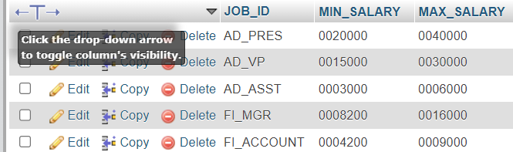

1. Write a MySQL query to append '@example.com' to email field.

Ans:- UPDATE employees SET EMAIL=CONCAT(EMAIL,'@example.com');

1. Write a [MySQL](https://www.w3resource.com/mysql-exercises/string-exercises/) query to find all employees where first names are in upper case.

Ans:- SELECT * FROM employees WHERE FIRST_NAME= BINARY UPPER(FIRST_NAME);

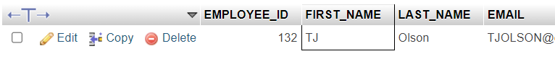

1. Write a MySQL query to get the locations that have minimum street length.

Ans:- SELECT MIN(LENGTH(STREET_ADDRESS)) FROM locations;



1. Write a MySQL query to display the first word from those job titles which contains more than one words.

Ans:- SELECT SUBSTR(JOB_TITLE,1,INSTR(JOB_TITLE,' ')) FROM jobs;

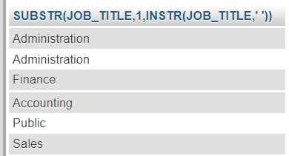

1. Write a MySQL query that displays the first name and the length of the first name for all employees whose name starts with the letters 'A', 'J' or 'M'. Give each column an appropriate label. Sort the results by the employees' first names.

Ans:- SELECT FIRST_NAME, LENGTH(FIRST_NAME) FROM employees WHERE FIRST_NAME LIKE 'A%' OR FIRST_NAME LIKE 'J%' OR FIRST_NAME LIKE 'M%' ORDER BY FIRST_NAME;

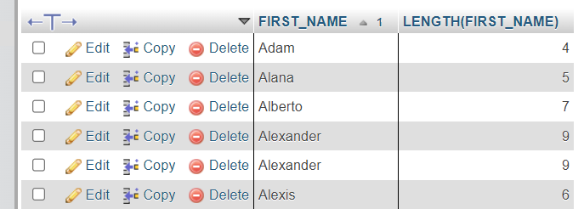

1. Write a MySQL query to display the first name and salary for all employees. Format the salary to be 10 characters long, left-padded with the $ symbol. Label the column SALARY.

Ans:- SELECT FIRST_NAME, LPAD(SALARY, 10, '$') SALARY FROM employees;

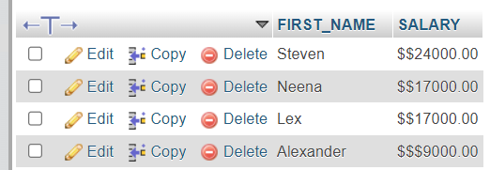

1. Write a MySQL query to get the employee id, first name and hire month.

Ans:- SELECT EMPLOYEE_ID, FIRST_NAME, MONTH(HIRE_DATE) FROM employees;

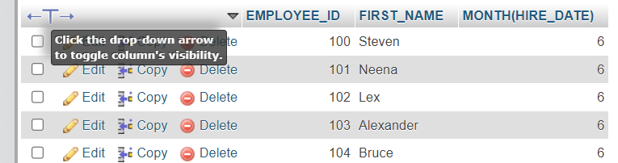

1. Write a MySQL query to get the employee id, email id (discard the last three characters).

Ans:- SELECT EMPLOYEE_ID,REVERSE(SUBSTR(REVERSE(EMAIL),4)) FROM employees;

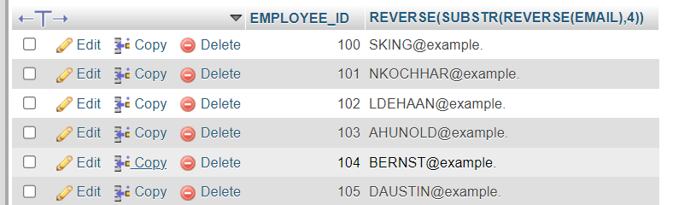

1. Write a MySQL query to extract the last 4 character of phone numbers.

Ans:- SELECT RIGHT(PHONE_NUMBER,4) FROM employees;

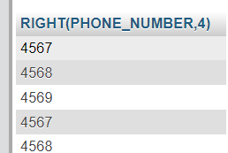

1. Write a MySQL query to display the first name and last name for employees where first occurrence of last name contain character 'c' after 2nd position.

Ans:- SELECT FIRST_NAME, LAST_NAME FROM employees WHERE INSTR(LAST_NAME, 'C')>2;

